**Name:- Om Ramakant Parvate Div:-"B" Roll.no 168 Batch:-B6**

**Practical no 1:- Web 2 Perform Arithmatic Opration**

<!DOCTYPE html>

<html lang="en">

<head>

    <title>Document</title>

</head>

<body>

    <script>

        let num1=30;

        let num2=10;

        let addition = num1 + num2;

        console.log("Addition:" + addition);

        let subtraction = num1 - num2;

        console.log("subtraction:" + subtraction);

        let multiplication = num1 * num2;

        console.log("multiplication:" + multiplication);

        let division = num1 / num2;

        console.log(" division:" + division);

    </script>

</body>

</html>

**Output:-**

­­­­­­­­­­­­­­­­­­­­­­­­­­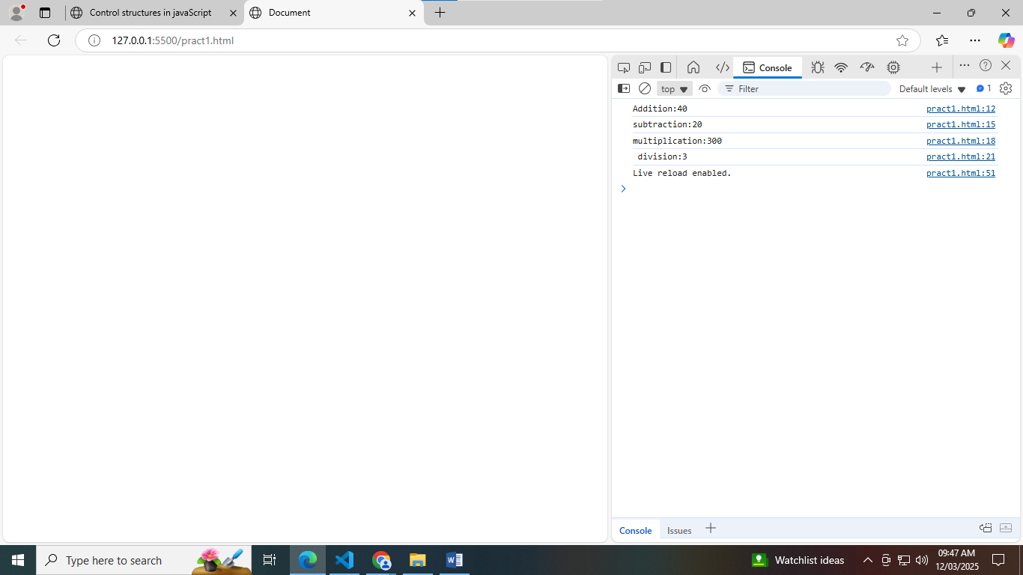

**Name:- Om Ramakant Parvate Div:-"B" Roll.no 168 Batch:-B6**

**Practical no 2:- Control Structure : Implement a JavaScript program using if-else statement and loops**

<!DOCTYPE html>

 <html>

 <head>

    <title>Control structures in javaScript</title>

 </head>

 <body>

    <script>

        let number=10;

        if (number > 0)

    {

        console.log(number + "is positive number.");

    }

    else if (number > 0)

    {

        console.log(number + "is nagaitive number.");

    }

    else

    {

        console.log("The number is zero.");

    }

    console.log("\nNumber from 1 to 5:");

    for(let i = 1; i<= 10; i++)

    {

        console.log(i);

    }

    console.log("\nNumber from 1 to 10 using while loop:");

    let i =1;

    while(i<=10)

    {

        console.log(i);

        i++;

    }

    </script>

 </body>

 </html>

**Output:-**

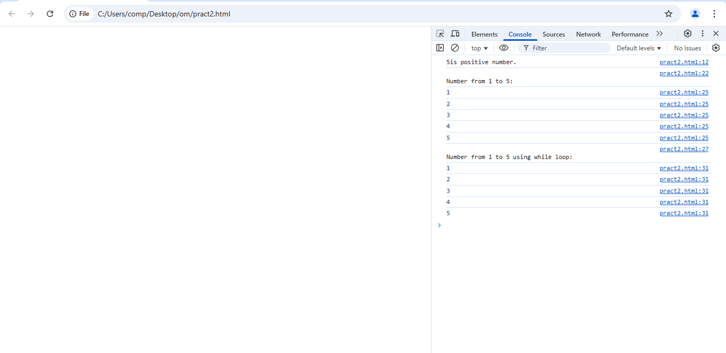

**Name:- Abhay Ulhas Kumawat Div:-"B" Roll.no 176 Batch:-B6**

**Practical no 3:- Function**

<!DOCTYPE html>

<html>

<head>

<title>Javascripts function</title>

</head>

<body>

<script>

function addNumber(a,b) {

return a+b;

}

function calculateArea (radius) {

return Math.PI*radius*radius;

}

function greetuser(name) {

console.log("Hello," + name + "!");

}

function introduce(name = "Guest")

{

console.log("welcome,"+ name + "!");

}

function isEven(number)

{

if (number % 2 === 0){

console.log(number + " is an even number.");

} else {

console.log(number + " is an odd number.");

}

}

let sum = addNumber(50,50);

console.log("sum of 50 & 50: + sum");

let area = calculateArea (6);

console.log("Area of the circles:"+area.toFixed(2));

greetuser("pawan");

greetuser("pooja");

introduce("pawan")

introduce("pooja")

isEven(12);

isEven(7);

</script>

</body>

</html>

**Output:**

